📄 Milestone 2 Report
AI-Driven Revenue Analysis for Hotels
Milestone 1: Orientation & Data Loading
Submitted by Team-B :
- Moravaneni Aiswarya Lakshmi
- Syed Naveed Muzammil
- Lakshmi Kalyani Akula

1. Introduction
In the hospitality industry, revenue optimization and occupancy management are critical factors that directly influence profitability. Hotels generate large volumes of booking data every day, but without proper analysis, this data cannot be effectively utilized for decision-making.
The objective of this project, AI-Driven Revenue Analysis for Hotels, is to analyze historical hotel booking data and derive meaningful revenue insights using Power BI. The ultimate goal is to enable data-driven decisions related to pricing, cancellations, customer segmentation, and booking trends.
Milestone 1 focuses on understanding the dataset structure, loading the data into Power BI, and performing systematic preprocessing and cleaning to prepare the dataset for further modeling and business analysis.

2. Dataset Source and Description
The dataset used for this project was collected from Kaggle, a widely recognized platform for real-world datasets and machine learning projects.
The dataset contains booking records for two hotel types — City Hotel and Resort Hotel. For Milestone 2, both hotel categories were retained to enable comparative analysis of revenue patterns across property types.
Access the dataset here:
🔗 https://www.kaggle.com/code/farzadnekouei/hotel-booking-cancellation-prediction/input

Dataset characteristics:
- Domain: Hospitality / Hotel Bookings
- Time period: 2015 – 2017 (3 years)
- Type: Historical booking transactions
- Granularity: One row per booking
- Size: ~120,000+ records
- Format: CSV
This multi-year dataset allows the analysis of:
- Seasonal trends
- Yearly revenue growth
- Cancellation patterns
- Customer behavior changes over time
Using three years of data provides sufficient historical depth for building meaningful analytical insights and future AI-driven forecasting models.

3. Objective of Milestone 1
The primary objective of this milestone is to transform raw booking data into a clean and structured dataset ready for analysis.
Key goals include:
- Understanding dataset structure
- Importing data into Power BI
- Identifying data quality issues
- Cleaning missing and inconsistent values
- Assigning correct data types
- Creating derived business columns
- Preparing data for modeling and DAX calculations
Without proper preprocessing, business metrics such as revenue and cancellation rate would be inaccurate.

4. Data Loading Process
The dataset was imported into Power BI Desktop using the Get Data functionality. 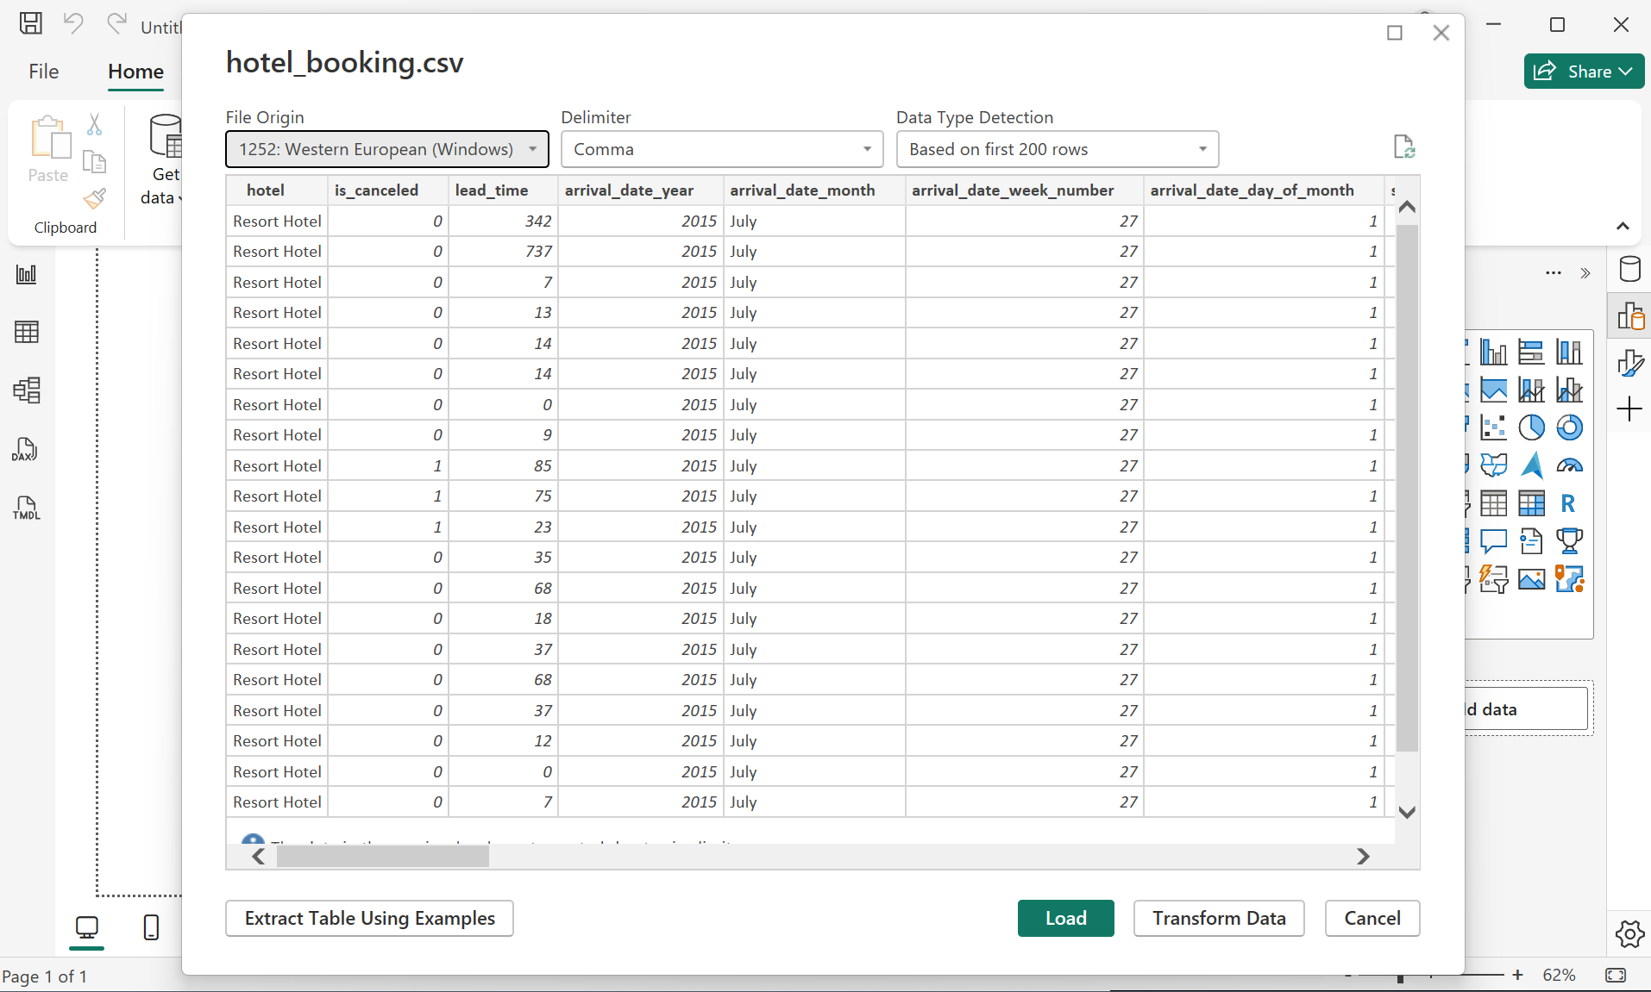 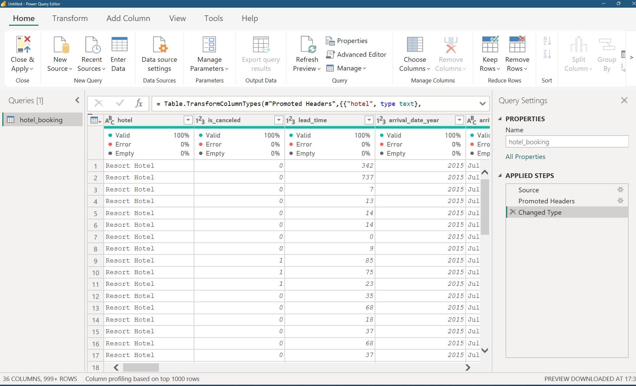
Steps performed:
- Loaded CSV file into Power BI
- Opened Power Query Editor
- Promoted first row as column headers
- Inspected preview for structure and correctness
Power Query Editor was selected for transformation because it allows repeatable and automated preprocessing steps before loading the data model.
This ensures:
- faster dashboards
- reduced memory usage
- better performance

5. Data Cleaning and Preprocessing
Raw datasets typically contain inconsistencies such as null values, incorrect formats, and irrelevant fields. Multiple preprocessing steps were performed to ensure high data quality.

5.1 Removing Irrelevant Columns
Columns containing personally identifiable information were removed:
- Name
- Email
- Phone number
- Credit card
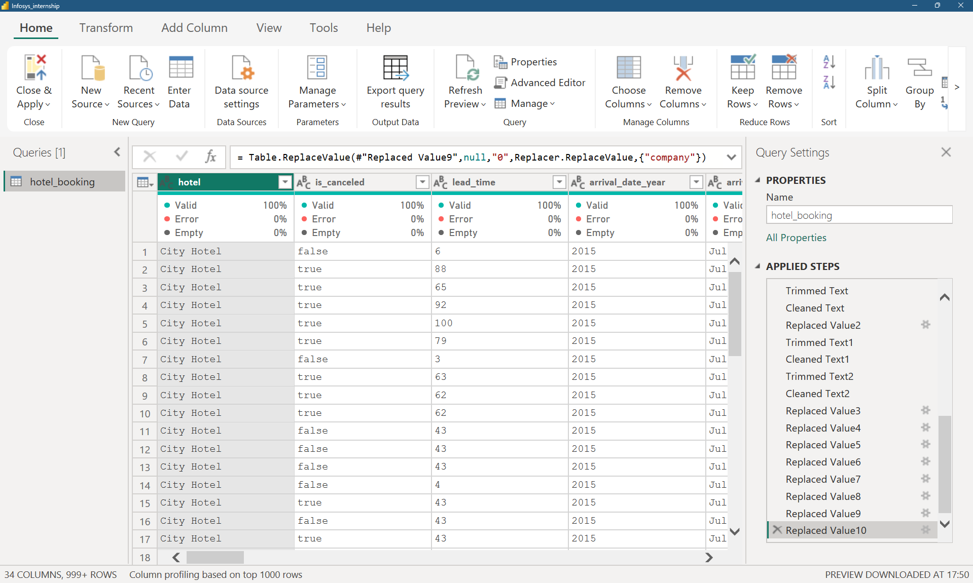
Reasons:
- No contribution to revenue analysis
- Increased memory usage
- Privacy and security concerns
Removing unnecessary attributes improved performance and simplified the data model.

5.2 Data Type Standardization
Correct data types were assigned to all fields:
Data Type | Example Columns
Whole Number | nights, adults, bookings
Decimal | ADR
Date | reservation date
Text | country, segment
Boolean | cancellation flag
Correct types ensure:
- accurate calculations
- faster queries
- reliable aggregations

5.3 Handling Missing Values
Missing values were handled logically based on business meaning rather than blindly deleting records.
Column | Treatment | Reason
children | replaced with 0 | no children present
agent | replaced with 0 | direct booking
company | replaced with 0 | individual booking
country | replaced with “unknown” | missing category
This approach preserved revenue records while maintaining data integrity.

5.4 Cleaning Blank and Inconsistent Text
Text inconsistencies such as:
- extra spaces
- empty strings
- mixed case values
were corrected using:
- Trim
- Clean
- Replacement with null/standard values
This ensures proper grouping in reports and avoids fragmented categories.

5.5 Creation of Derived Business Columns
To simplify analysis, new calculated fields were created.
Total Nights
Represents the total stay duration:
weekend nights + weekday nights
Revenue
Represents booking revenue:
ADR × Total Nights
Canceled bookings were assigned zero revenue.
These derived columns reduce complexity in later calculations and improve performance.

6. Data Validation
After preprocessing, several checks were performed:
- No critical null values remain
- Correct data types applied
- Revenue calculation verified
- Canceled bookings generate zero revenue
- Dataset reduced to relevant fields only
This ensures reliable inputs for modeling and analytics.

7. Outcome of Milestone 1
At the end of this milestone:
- Raw data was successfully loaded into Power BI
- Data inconsistencies were resolved
- Missing values handled logically
- Derived revenue metrics created
- Dataset optimized for performance
The data is now fully prepared for:
- Milestone 2: Data Modeling
- Milestone 3: DAX & Business Metrics
- Milestone 4: Visualization & AI-driven insights
This clean and structured foundation enables accurate and meaningful revenue analysis.
🏨 Milestone 2: Data Modeling & DAX Implementation
1. Objective of Milestone 2
The objective of Milestone 2 is to transform the cleaned dataset into an optimized analytical model within Power BI. This phase focuses on structuring the data for efficient analysis, establishing relationships between tables, creating calculated measures using Data Analysis Expressions (DAX), and developing an initial interactive dashboard to support revenue insights
2. Updated Dataset Description
The dataset consists of hotel booking records collected from Kaggle, covering a period of three years from 2015 to 2017. It includes booking information for two types of properties:
- City Hotel
- Resort Hotel
For Milestone 2, both hotel categories were retained to enable comparative analysis of revenue patterns across different hotel types. The dataset contains approximately over 100,000 records with attributes related to customer demographics, booking characteristics, stay duration, pricing, and service preferences.3. Data Modeling
After data cleaning, the dataset was structured into a logical data model within Power BI to support efficient querying and analysis.
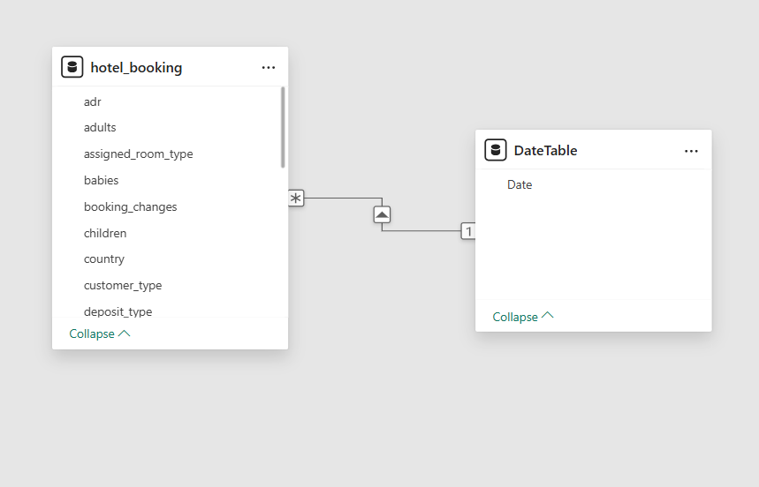
3.1 Fact Table
The primary fact table used in the model is:
hotel_booking
This table contains transactional booking records and numerical measures such as revenue, number of nights, and pricing.

3.2 Dimension Table — Date Table
A separate Date table was created to enable time-based analysis. The Date table contains continuous date values covering the entire range of booking dates in the dataset.

3.3 Relationships
A relationship was established between the booking data and the Date table:
- hotel_booking[reservation_status_date] → DateTable[Date]
- Relationship Type: Many-to-One (*:1)
- Cross-filter Direction: Single
- Relationship Status: Active
This structure allows accurate analysis of trends over time, including monthly and yearly revenue patterns.

3.4 Schema Structure
The model follows a star-schema-like structure:
- Fact Table: hotel_booking
- Dimension Table: DateTable
This design improves performance and simplifies reporting.

4. DAX Calculations
Several DAX measures were created to compute key performance indicators required for revenue analysis. These measures dynamically respond to filters and slicers applied in the dashboard.

4.1 Total Revenue
Calculates the total income generated from bookings.
Total Revenue = SUM(hotel_booking[revenue])

4.2 Total Bookings
Counts the number of bookings.
Total Bookings = COUNTROWS(hotel_booking)

4.3 Average ADR (Average Daily Rate)
Represents the average price per room per night.
Average ADR = AVERAGE(hotel_booking[adr])

4.4 Revenue per Booking
Measures average revenue generated per booking.
Revenue per Booking = DIVIDE([Total Revenue], [Total Bookings])

4.5 Total Nights
Calculates the total number of nights stayed.
Total Nights = SUM(hotel_booking[total_nights])

4.6 Revenue per Night
Shows average revenue earned per night.
Revenue per Night = DIVIDE([Total Revenue], [Total Nights])

5. Initial Dashboard Development
An interactive dashboard was developed to visualize key insights from the dataset. The dashboard provides an overview of revenue performance, customer behavior, booking characteristics, and geographic distribution.
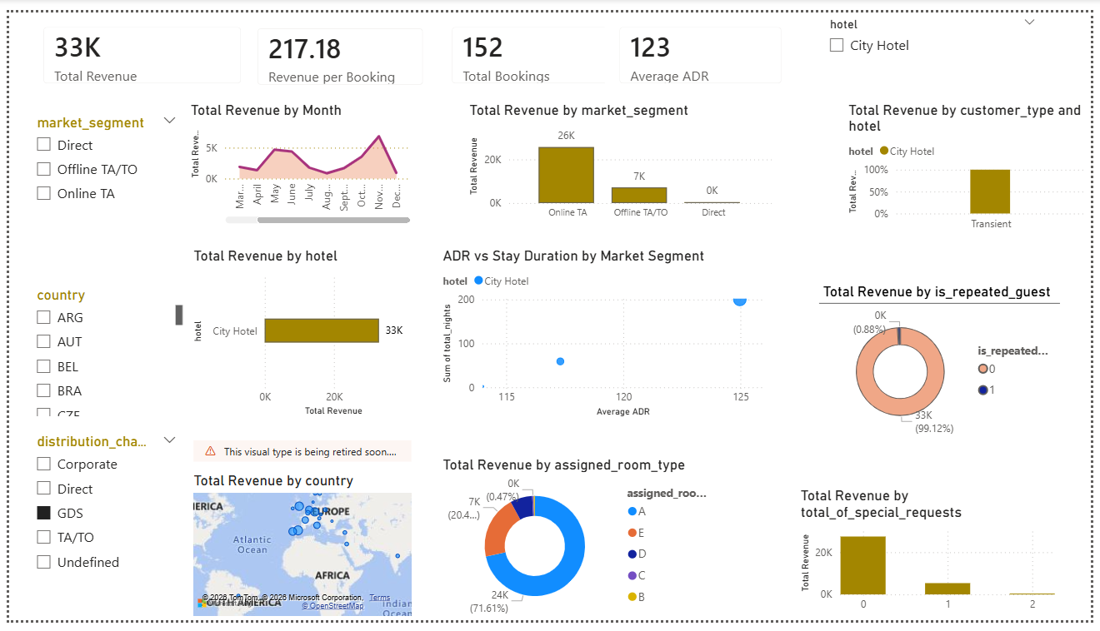

5.1 Key Performance Indicators (KPIs)
The top section of the dashboard displays summary metrics:
- Total Revenue
- Total Bookings
- Average ADR
- Revenue per Booking
These indicators provide a quick overview of operational performance.

5.2 Revenue Trend Analysis
A line chart was used to display revenue trends over time. This visualization helps identify seasonal patterns and fluctuations in booking activity across months and years.

5.3 Market Segment Analysis
Revenue was analyzed across different market segments such as Online Travel Agents, Offline Agents, Direct bookings, and Corporate clients to identify the most profitable customer groups.

5.4 Customer Type Analysis
Revenue contributions were compared across customer types (e.g., Transient, Group, Contract) to understand booking behavior and demand patterns.

5.5 Hotel Performance Comparison
Revenue generated by City Hotel and Resort Hotel was compared to evaluate performance differences between property types.

5.6 Geographic Analysis
A map visualization was used to show the distribution of revenue by country, providing insights into international demand.

5.7 Room Type Analysis
Revenue was analyzed based on assigned room types to identify which categories generate the highest income.

5.8 Relationship Analysis
A scatter plot was created to examine the relationship between pricing (ADR), stay duration, and revenue across market segments.

5.9 Booking Characteristics Analysis
Additional charts were included to analyze factors such as:
- Repeat vs. new guests
- Number of special requests
- Booking modifications
These insights help understand customer engagement and service expectations.

6. Interactivity Using Filters (Slicers)
Interactive slicers were added to enable dynamic filtering of the dashboard. Users can customize the analysis based on specific criteria.
Filters implemented include:
- Hotel Type (City vs. Resort)
- Market Segment
- Country
- Distribution Channel
- Customer Type
- Booking Date
These filters allow deeper exploration of revenue patterns across multiple dimensions.

7. Insights Enabled by the Model
The data model and dashboard together support analysis of:
- Revenue trends over time
- Performance differences between hotel types
- Contribution of various customer segments
- Geographic demand patterns
- Impact of pricing and stay duration
- Customer loyalty and booking behavior

8. Conclusion of Milestone 2
Milestone 2 successfully transformed the cleaned dataset into a structured analytical model using Power BI. Relationships were established, key performance measures were developed using DAX, and an initial interactive dashboard was created. This foundation enables advanced analysis and storytelling in subsequent milestones.

9. Next Steps — Milestone 3
The next phase will focus on advanced DAX calculations, development of business metrics, performance indicators, and deeper analytical insights to support data-driven decisi

